8.86: (a) For momentum to be conserved, the two fragments must depart in opposite directions. We can thus write
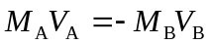
Since 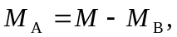we have
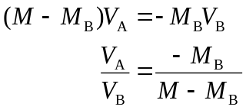

Then for the ratio of the kinetic energies

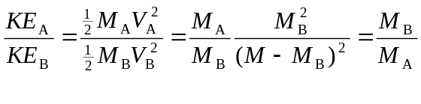
The ratio of the KE’s is simply the inverse ratio of the masses.
From the two equations
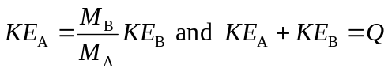
We can solve for 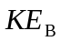to find
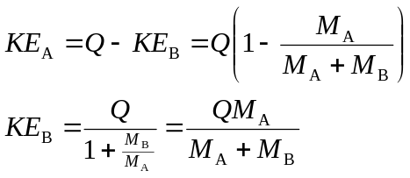
(b) If 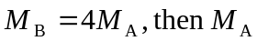 will get 4 times as much KE as 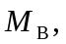or 80% of Q for 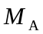and 20% for 